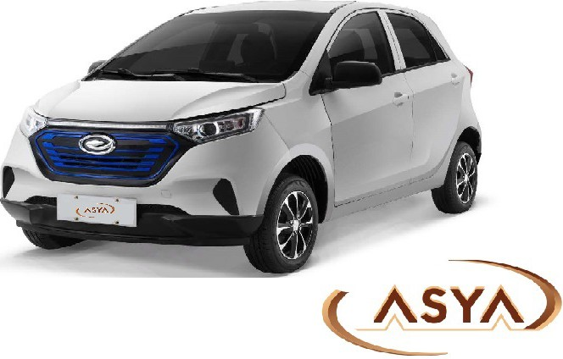

Quotation

FOB : USD 9,600 Unit FOB TIANJIN

V7 specification
" | Item | corrt errt
I | It.,..l:\0 |  | LEI
2 | Source code |  | EA92
3 | lli:ulal type |  | Two wheel driv:ing
4 | T&elmical .tate |  | BEV
5 | Dri'rillc tJJ• |  | RWD
6 | sp eificatiou | '"ength(llllll) | 3400
7 |  | fvidtMnm) | 1500
8 |  | eight (llllll) | 1500
9 |  | 'lheel base (llllll) | 2385
10 |  | Tread (mm)frant/rear | 1290/1310
12 |  | ax total mass (kg) | 950
13 |  | urb weight (kg) | 650kgs (no battery)
14 |  | le weight quality(kg)front/ rear | 338/390

15 |  | eats (passenger) | 4
16 | base specification | ax speed (actual) (km/h) | 65
17 |  | ax speed (show) (km/h) | 70
18 |  | conomi c speed (actual)(km/h) | 40
19 |  | ax gradeability % | 20
20 |  | in clearance (nonload/full load) (mm) | 153/123
21 |  | in turning diameter (m) | <10
22 |  | ileage (km) (Uniform velocity method ) | 45km/h 95
25 |  | raffic noise (db) | ::S74
26 | Suspension structure | Front suspension | McPher son Independent Suspension
27 |  | ear suspension | Drag and drop arm type non-independent suspension
29 | tire | luminium alloy rim | •
30 |  | tire specificat ion | 155/65R13
31 |  | tire pressure (kpa) front/rear | 250/250
32 |  | heel hub specifi cat ion | 13-5J
35 | Steering | ain driver seat 4 way m anual  Fidjustm ent | •
36 |  | co-pilot seat 4 way manual adjustm ent | •
37 |  | Front seat headrest high-low  Fidjustm ent | •
38 |  | ack seat belt headrest | •
39 |  | the rear seat is reclined | •
40 |  | Knitting seat | •
43 |  | ype of steering gear | pinion-and-rack
44 |  | teer ing wheel size | 376
45 |  | teering disc m aterial | foam ing
48 |  | power-assisted steering | •
49 | braking | front/rear Brake type | Di sh/drum type
50 |  | !brake booster system | •
52 | Body structure | lbody models | m onocoque body

53 |  | lbody structure |  |  | 5 doors 4 seats
54 | Powertrain Parameters | otor type |  |  | PMSM
56 |  | ated power/speed (kw/r/m in) |  |  | 7.5/3000
57 |  | ated Voltage (V ) |  |  | 72
58 |  | ated torque (Nm ) |  |  | 20
59 |  | pe-De controll er |  |  | 72V/500W
61 |  | !battery mod el |  |  | integrated
62 |  | attery type |  |  | Lithium battery
63 |  | Power battery number |  |  | 7. 36kwh
64 |  | rated capacity (Ah) |  |  | 100
65 |  | 12VSmall battery and capacity |  |  | 36Ah
66 |  | harger model |  |  | 72-20
67 |  | charg ing tim e h |  |  | 5
68 |  | putput voltage (V) |  |  | 72
69 |  | aximum current (A ) |  |  | 25
71 | humanization design | he driver i s not wear ing a seat belt  fvarning device |  |  | •
73 |  | fvarning of Hand brake is not loose |  |  | •
74 |  | fvarning of the door open |  |  | •
75 |  | echanical key |  |  | - (one piece)
76 |  | rem ote key (spli t type) |  |  | - -
77 |  | rem ote key (integrated) |  |  | - Cone p iece)
84 | safe | olli sion requirement s |  |  | - (50krn/h)
86 |  | collapse type steering column |  |  | •
87 |  | Fron three-point safety belt
88 |  | ack three-point safety belt |  |  | •
91 |  | o-p ilot safe shake handshandle |  |  | •
92 |  | Parking sensors |  |  | •
94 | appearance | lectric adjustment of external rearview mirror |  |  | •
96 |  | external rearv iew mirror with side turr  signal |  |  | - (LED )
97 |  | external mirror folds manually |  |  | •
100 |  | echanical anti | - | glare rearv iew mirror | •
102 |  | m e color external rearv iew m irror |  |  | •

•

106 |  | Injection plastic bumpers | •
108 |  | lifting of glass | electric
110 |  | he main driving sun visor | •
113 |  | he co-pilot visor | •
116 |  | hark fin antenna | •
117 |  | oneless rain scraper | •
118 |  | !back door open way | Manual lasso
121 |  | Pocket covers | •
122 |  | o-p ilot storage containers | •
127 |  | igh power heater | •
129 |  | Fan/PTC switch | •
130 |  | ir conditioning (manual) | 0
132 |  | ontrol Panel | •
133 |  | ENTRAL LOCK | •
134 |  | r:;wi tch to lock - stop anti-theft devicE | •
135 |  | daytime running lamp s | •
136 |  | front fog lamp | •
137 |  | !rear fog lamp | •
138 |  | Power base (point cigarette socket) | •
140 |  | lectronic instrument di splay | •
141 |  | eter voltage di splay | •
142 |  | Instrum ent current di splay | •
143 |  | eter display | •
147 |  | attery heating system | 0
152 |  | ouch screen (9) | •
156 |  | external antenna | •
159 |  | high-fidelity speaker | •
162 |  | car coupler | •
163 |  | tools | •
164 |  | instruction book | •
165 |  |  | •
167 | car color |  | white

Pictures:



   

